**TIGER DETECTION WITH IMAGE PROCESSING**

**Image Localisation Attempt using Background Elimination:**

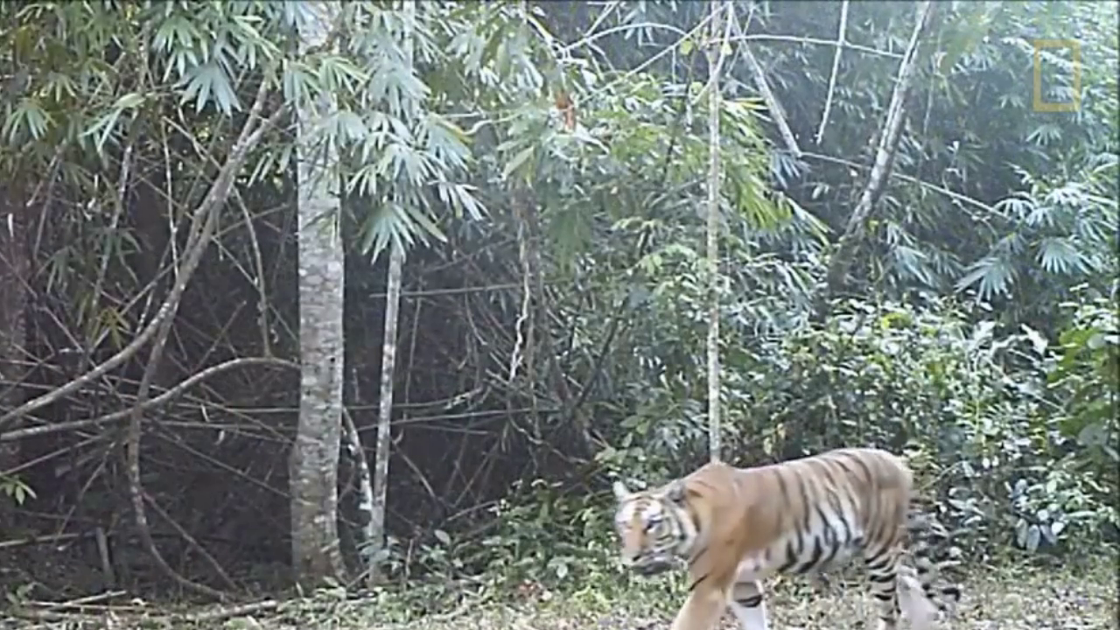

Video Feed

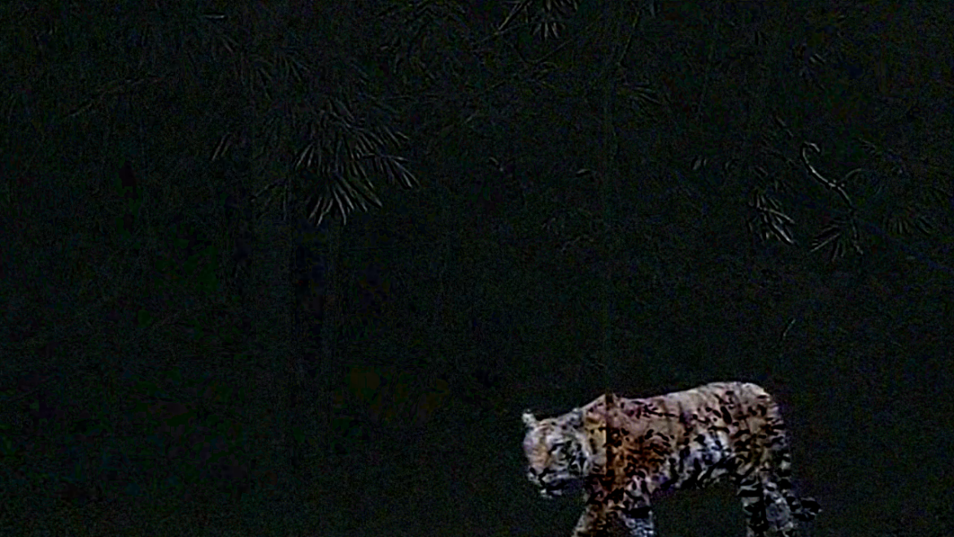

Background Elimination



Blurring and Canny Edge Detection

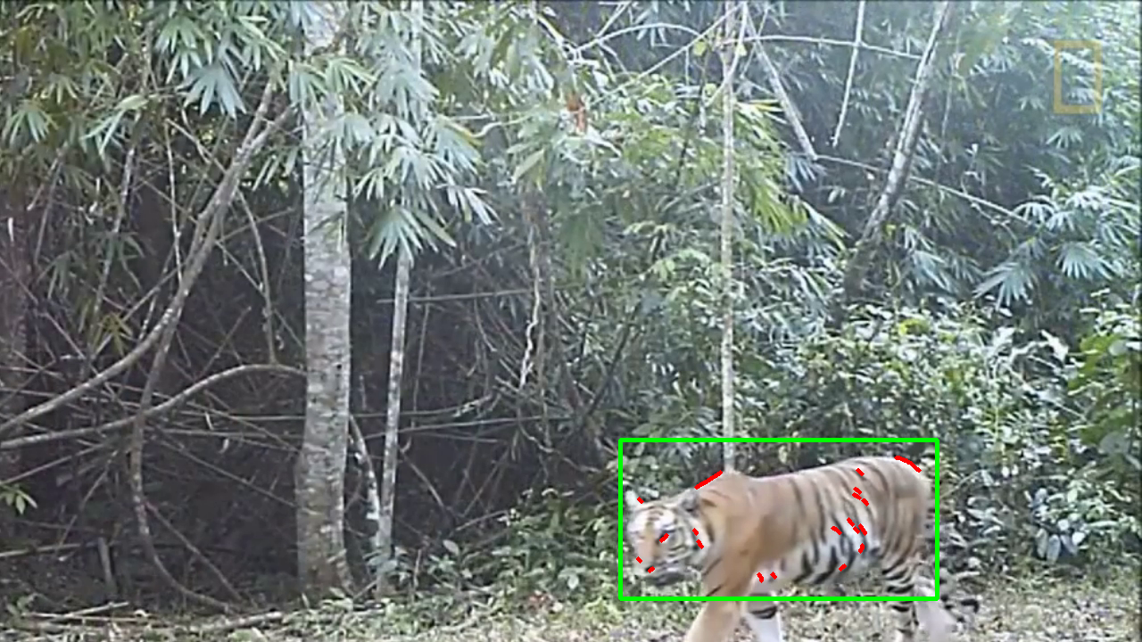

Contour detection and Boundary Box